Band Booster Meeting
Tuesday, July 28, 2026
8:00 pm
CVHS Band Room

Attendance:
Board Members: Steve W., Cindy V., Gloria W., Leanne R., Nate B.
Other Attendees: Marion G., Jill S., Heather & Chris S., Brian & Alyssa A., Eileen A., Candice R., Rami R.R, Sasmita P., Pearl P., Katia F., Linda N., Kris P., Greg L., Jennifer C., Kuyan S., Scott M., Jerry O., Allison P., Jen W., Desiree M., Michele O., Leia A., Amy B.
Call to Order-8:07 PM
- Band Director’s Report
  - Review of first two days of band camp
  - Goals are to make better musicians, have fun and good supportive culture
  - Requested parents assistance with volunteer opportunities
  - Communicate with him if there are problems through the Band App because he will respond more quickly (or email)

- Treasurer’s Report

  - Updates
    - Monthly Update
      - $55,825 Current cash balance
      - June 30, 2026 ended previous fiscal year (ended with profit)
      - REceived insurance renewal (up $160)
      - End of year financials are completed
      - Flag My Yard $645 (Guard fundraiser)--can still sign up for Labor Day
  - The Financial Summaries, covering June 1-June 30, 2026 were presented at the meeting. It is as follows:
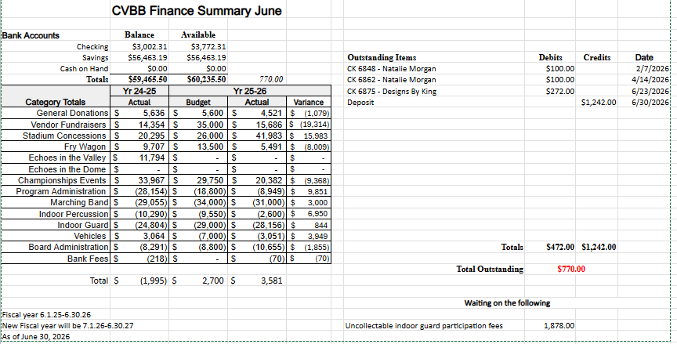

- President’s Report
  - Link: CUMBERLAND VALLEY BAND BOOSTER NEW FAMILY ORIENTATION

- Committee Reports

  - Fry Wagon
  - Fundraising
  - Future Fundraisers
  - Concessions

- Secretaries' Report

- New and Other Business

  - 2026/2027 Executive Board Appointment - New Recording Secretary

- Voting:
  - Treasurer’s Report: Passed Unanimously
  - June Minutes: Passed Unanimously

- Adjournment: 9:06 pm

The next Band Booster Meeting will be held on Tuesday, August 25, 2026
Executive Session - 6:30 pm
Band Booster Meeting - 8:00 pm
CVHS Band Room

