Band Booster Meeting
Wednesday, April 26, 2023
7:30pm via Google Meet

Attendance: Board Members: Derek, Laurie Beth, Karen, Deb, Chris, Ron, and Kim; Steph S., Kristen W., Val R., Stephen F., Brooks H., Kirk S., Shane W., Karen S., Amanda, Virgilio A., Mario D., Cat D., Nicole H., Amy C., Mike C., Amy M., Kara S., Kelly K., Elizabeth U., Stephen F., Jessica A., Amanda N., Katelyn S.,

Agenda – Booster Board Meeting

1. Call to Order - 7:37pm

2. Elections – live voting for the 7 positions
Final List of nominees for Ballot
*President Ron Vansteenacker - 24 yea
*1st Vice President Maureen Dyer - 25 yea
*2nd Vice President Amanda Nailor - 23 yea
*Treasurer Virgilio Arcega - 24 yea
*Assistant Treasurer Nicole Holland - 22 yea
*Recording Secretary Kristen Weitzel - 22 yea
*Corresponding Secretary Valerie Ryerson - 23 yea
Corresponding Secretary Laura Adamson - 3 yea

*New Board Members for the Cumberland Valley Marching Band Boosters 2023-2024
Current board members are willing to help new members in any capacity, especially Derek with Ron V.

3. President’s Report

a. Status of competitive program
No updates on school decision regarding the future of the program - focus is on numbers
Last school board meeting, Monday, April 17th, high turnout of support, very poised and passionate group represented the program with pride and RESPECT
Need to be present and sharing concerns especially student testimonials at all of the School board meetings
The next school board meeting is Monday, May 1, 2023 Board of School Directors meeting will begin at 7 p.m. in the District Office Board Room
Steve F. has reached out to his members - one member mentioned the time commitment for the program and is that the reason for the low numbers - explanation of how the hours vary based on the weekend and the
Cat D. reached out to Calvacade President and he emailed two school board members along with Dr. Rawls and Dr. Blanchard to keep the program going as Cumberland Valley is leader in the circuit offering a brand new stadium
Kristen asked about CV Board sub-committees and where CVMB may align. Also asked if CVMB could attend the sub-committee meetings? Response made during the meeting CVSD maintains a Booster committee; CVMB was never invited; may be inclusive to only PIAA sports teams.

There are board members who are assigned to Advisory Committee roles - could the Band Boosters join the advisory?
Val shared concerns about students being prepared to participate at the collegiate level and how will look be considered on college applications if students are in a PEP band and not at the competitive level - perhaps we can secure a band director at the collegiate level to share at the board meeting?
Steph - echoed the about how the students presented with grace and respect at the school board meeting
Steve - shared requirements of a local programs - Chambersburg - they practice every day before school in regards to the time requirement as addressed by one school board member
Val - Camp HIll requires all students to do Marching Band in order to participate in other music opportunities
Nicole - feeding the pipeline and the program is still recovering from COVID and rebuilding the program as her family has noticed a difference with having two children several years apart both in the same music program
Kara - her son received a letter from the Music Department in middle school as part of a letter campaign from Mr. Porter - Steve believes that to have been a one-time outreach

b. Chaperoning guidelines being updated
Coaches and staff are taking a closer look at the guidelines
Updated Guidelines to be posted on website
WGI required all those being in contact with students to complete Safe Sport training ($20 - $17 with coupon and 1.5 hours to complete online training) - perhaps the board wants to require volunteers to participate in a similar training for best practice - cost and time of training to be considered
Chaperones need to be with students and AT POST and at ALL times
Mario - asked to consider cost of training as chaperones are already at a premium
Kirk - what about props and which volunteer roles would need the training?
Chaperones sign a written acknowledgement that they read the guidelines and will adhere to the requirements

4. Director’s Report

Steve provided the following updates:
Percussion meeting Mondays and Wednesdays in preparation of middle school performances
Eagle View is May 9th and Mountain View is May 11th - volunteers are needed
Marching Band staff met last weekend to discuss three rookie camps in May, rehearsal schedule at Chapman Fields there are requests that need to go through the proper chain of command to secure field
No Band Director at this time - staff is planning a theme and moving forward in hopes the new director will embrace plans as TIME is of the essence
TIME is delaying the program with each passing day the program does not secure a Band Director

5. Treasurer’s Report

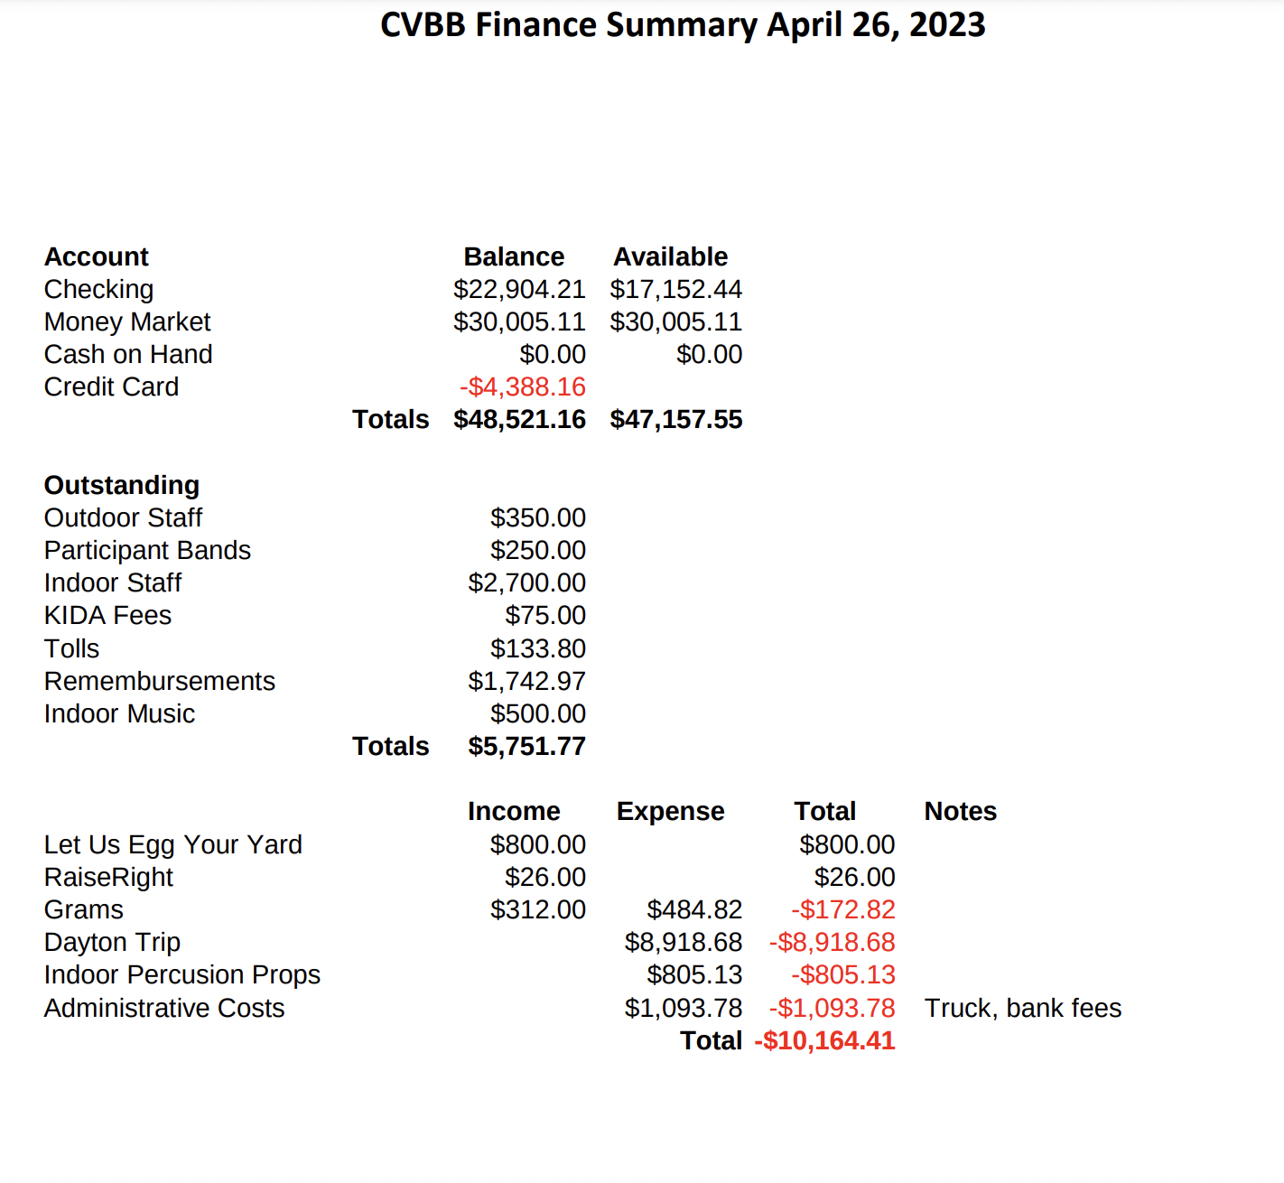

a. Vote on 2023-2024 preliminary budget
Motion made to pass the 2023-2024 preliminary budget by Ron and seconded by Shane with 21 yea votes

b. Vote on indoor percussion expenditure (harnesses)
Steve requested to use under budget funds and and some additional money to repair equipment
Motion was made to approve percussion expenditure (haresses) for $2,050.00 by Kirk and seconded by Kristen with 19 yea votes

6. Indoor Update

a. Color Guard
Katelyn provided the following when she joined the meeting:
She was late to the meeting, but was kept updated on meeting discussions and is in support of a Safe Sport training program - consider cost and time of program
Supports written acknowledgement of chaperoning guidelines to eliminate concerns about coaches and parents
Equipment pick up at Monroe Elementary on Thursday, April 27th at 6pm
Provide Safe Sport Training certifications from WGI to Derek as requested to have on file for audit

b. Percussion
Steve shared out his update in Director’s Report

7. Secretary’s Report

8. Committee Reports

a. Fundraising
i. Yard signs - going well, slowly being picked up - $300 to $400 in profit
b. Fry Wagon
i. Mountain View Cultural Event 4/27 - coverage is good
ii. Lacrosse at Eagle View 5/2 - senior night 5-8pm serving food
iii. Sporting Hill May Fair 5/12
iv. Fun Food Fest (Hampden Twp) 7/8

Chris divided Fry Wagon shifts into two slots to offer more variety and shorter shifts - also need to post events on Facebook in hopes to attract volunteers

9. New Business
Kara - two small freezers on visitors side, lots of crock pots (40), pots and pans need cleaned out as new countertops to not allow the freezers to be able to be plugged in, Val and Kara met with facilities and there is to be a walk-in freezer on the outside of the Home Side
Ron - need to consider a replacement for him as he will be an outgoing parent of a senior and he is the only one with the Servsafe certification
Elizabeth - equipment sheds near Chapman Fields - who do we talk to move them? Derek to check
Mario - survey where to pour concrete for pads for sheds
Steve - lots of stuff needs to come out or go to auction if sheds are moved and under the direction of the new Band Director
Indoor Banquet Saturday, May 20th at 1pm Stover Farm

Motion to adjourn meeting at 8:50pm by Laurie and seconded by Shane

Next meeting: May 18th 6:30pm Executive Session followed by Band Booster Meeting at 7:30pm

